
Unit 29 Travel (Speaking)
Website: www.sinera.eu/English4U
Facebook: https://www.facebook.com/English4U1

A. Travelling on holiday
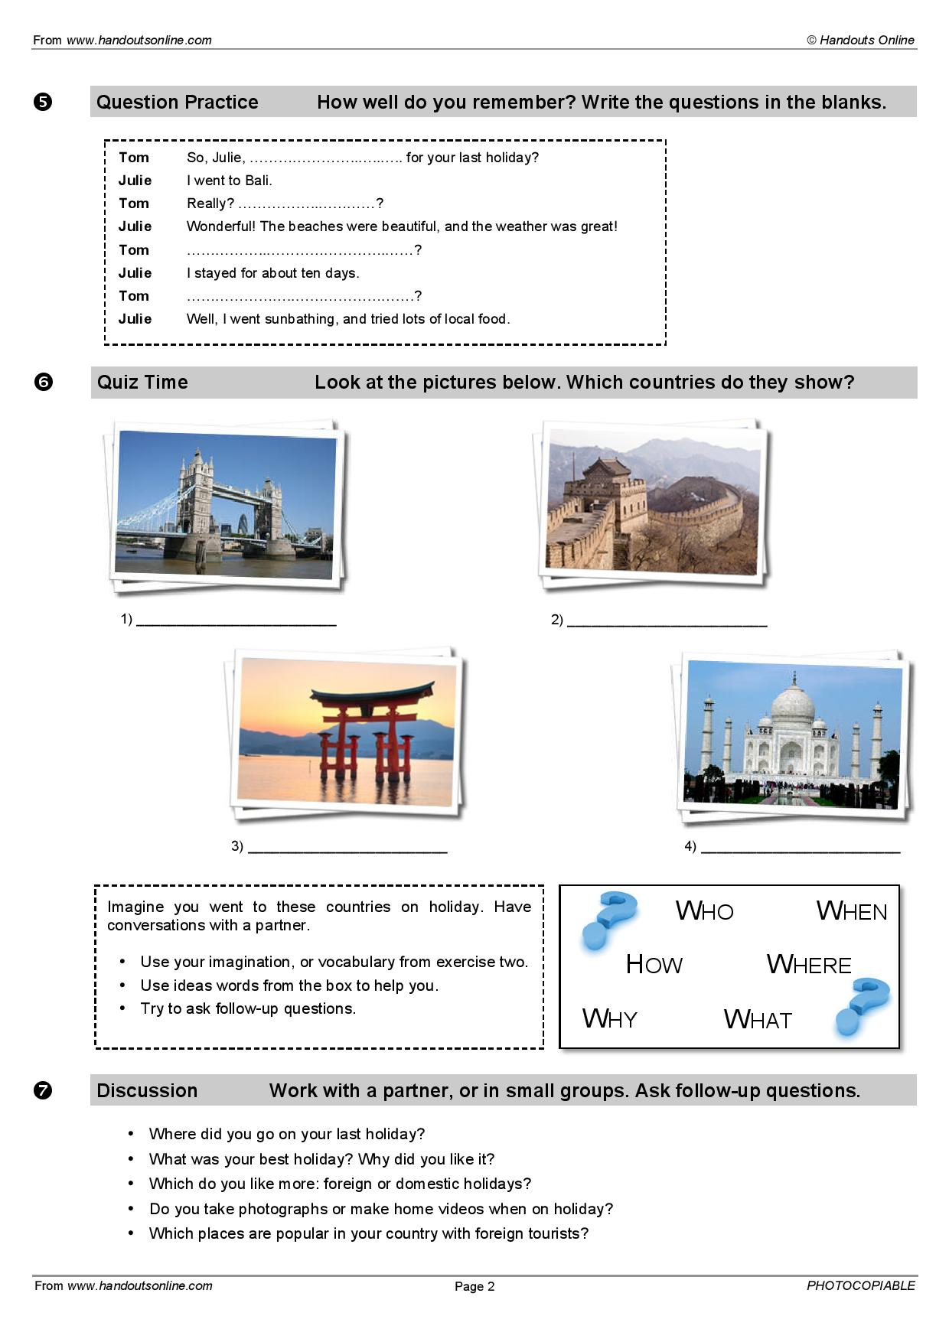

B. Places

